**Software Design Document**

**Project: Finance Notebook**

**Team: Finance Robot**

Ma Yixiao

Jiang Lihao

Liu yangyu

Liu Shiying

**1 Introduction**

**1.1 Purpose**

The purpose of this document is to describe the implementation of the Finance Notebook. The Finance Notebook is a personal finance manager software which is designed to help users track their spending by allocating transactions into individual categories and manage their budget.

**1.2 Scope**

This document describes the implementation details of the Finance Notebook. The software will consist of two major functions. First to help users track and manage their spending , and the second to help users manage their budget.

**2 Design Overview**

**2.1 Description of Problem**

Traditional personal finance Manager application are often limited to providing little and default categories for users to manage their spending and also requiring users to add their transactions on their own which sometimes can be inconvenient.

The Finance Notebook will provide a convenient finance management service and a friendly customer interface for users to manage finance easily and efficiently.

**2.2 Solution**

1. for limited categories:

The Finance Notebook provides default categories for users to choose and allow users to add/remove or change their categories to suit their own needs.

1. for adding transactions:

The Finance Manager help users import their transactions. If the user need to add huge amount of transactions, the Finance Manager will import them automatically. But if the user just want to add some transactions manually, they can do that on our website as well.

**2.3 Technologies Used**

For the front-end, the development environment is Microsoft Visual Studio Code 1.49. We use angular to build the application.

For the back-end, the develop environment is IntelliJ IDEA. We use SpringBoot 2.3.3 to build the application and MongoDB 4.4.0 to store data.

**2.4 System Architecture**

Figure 1 shows the use case diagram for the system.

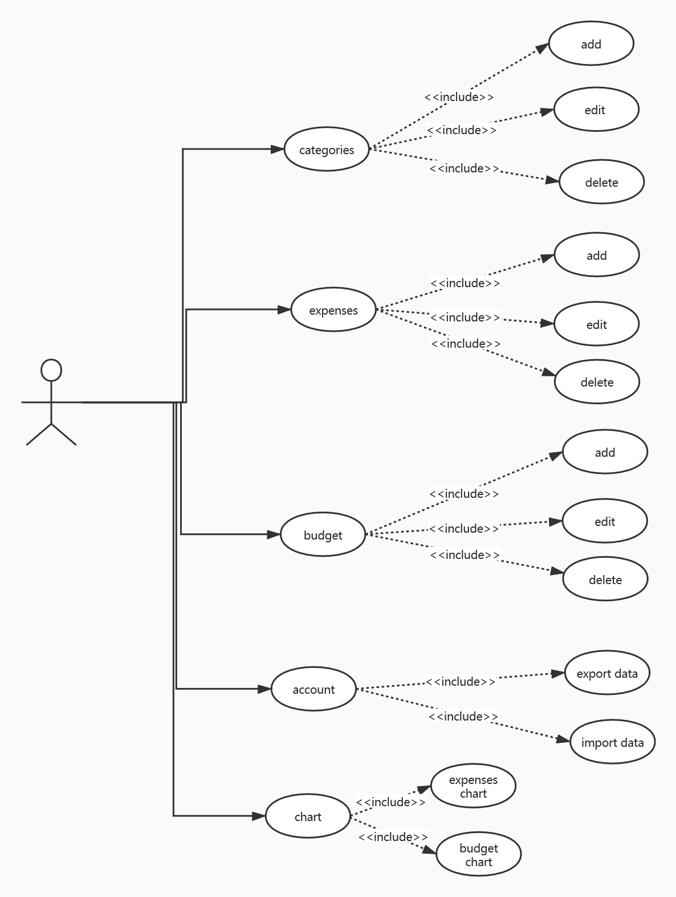

Figure 1

Figure 2 shows the domain model for the system.

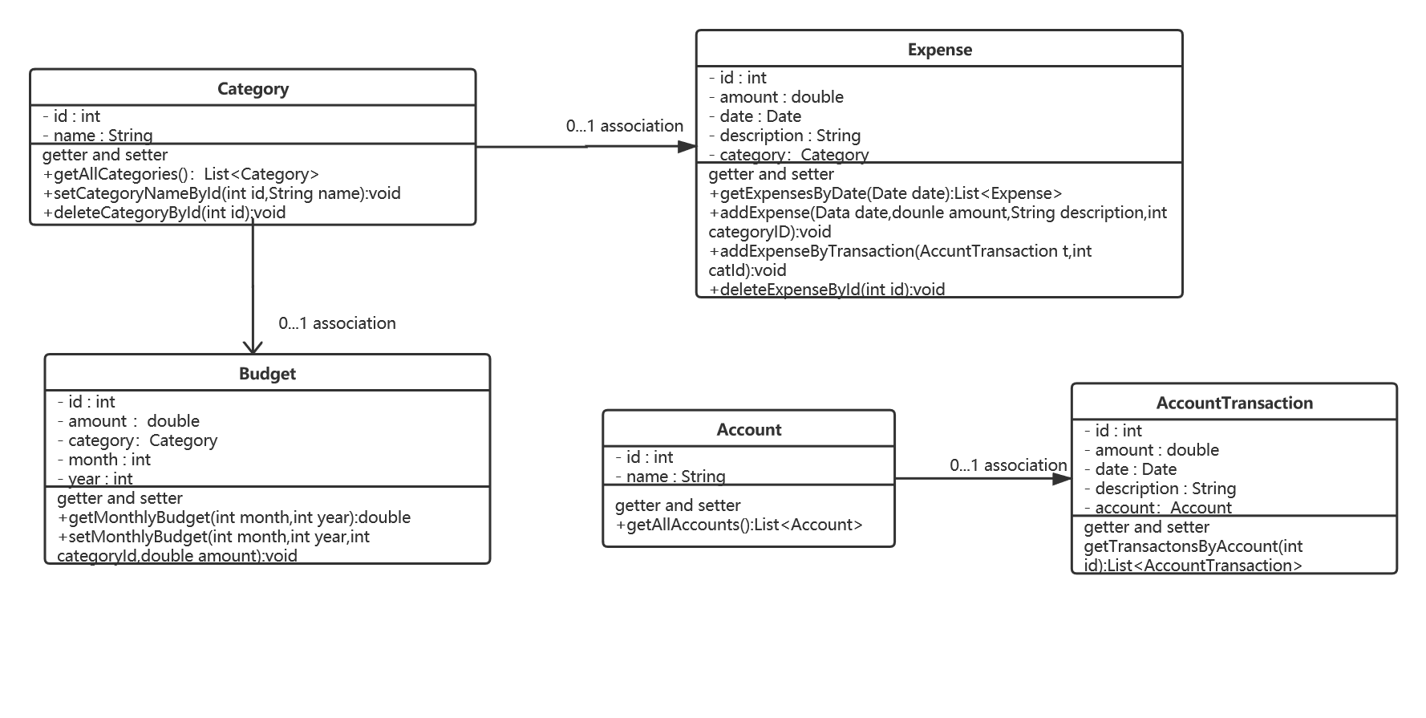

Figure 2

Figure 3 shows the Class diagram for the system

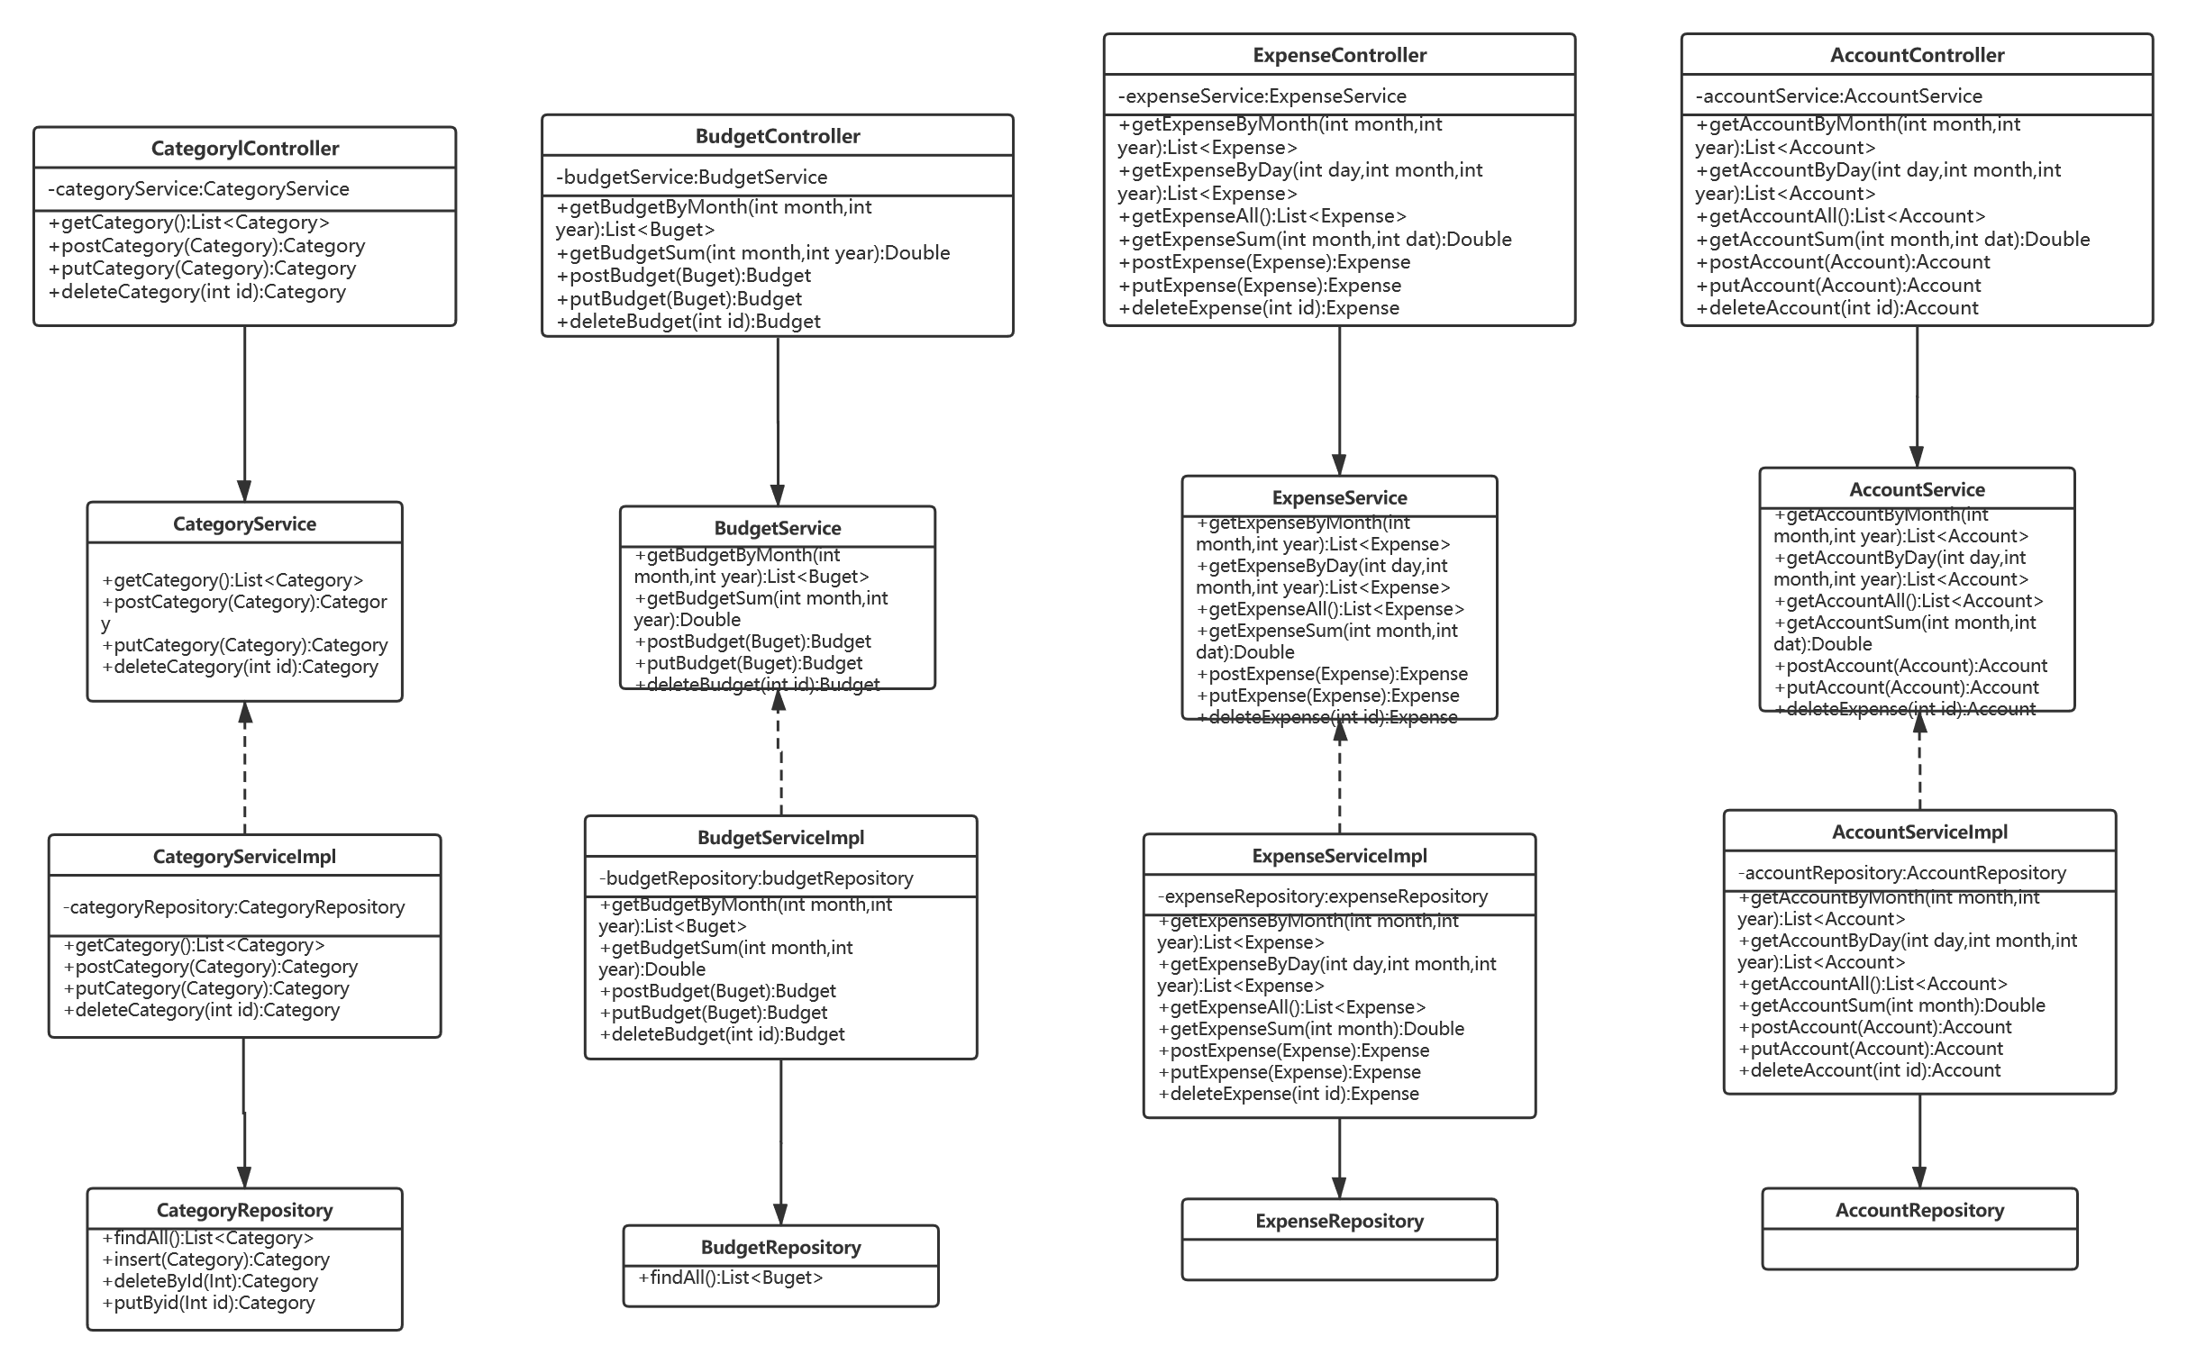

Figure 3

**2.5 Features and Priority**

1.Category management:

Description: Provide default categories and help users customize their own categories.

Priority: High

1. Transactions import:

Description: help users import transactions automatically and also provide friendly interface for users to add them manually.

Priority: High

1. Expense management:

Description: help users organize their expenses.

Priority: High

1. Budget management:

Description: help users set their monthly budget and yearly budget.

Priority: High